Class Design - Model

# Create Initial Design Classes

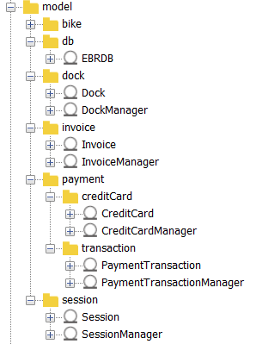

# Define Relationships Between Classes

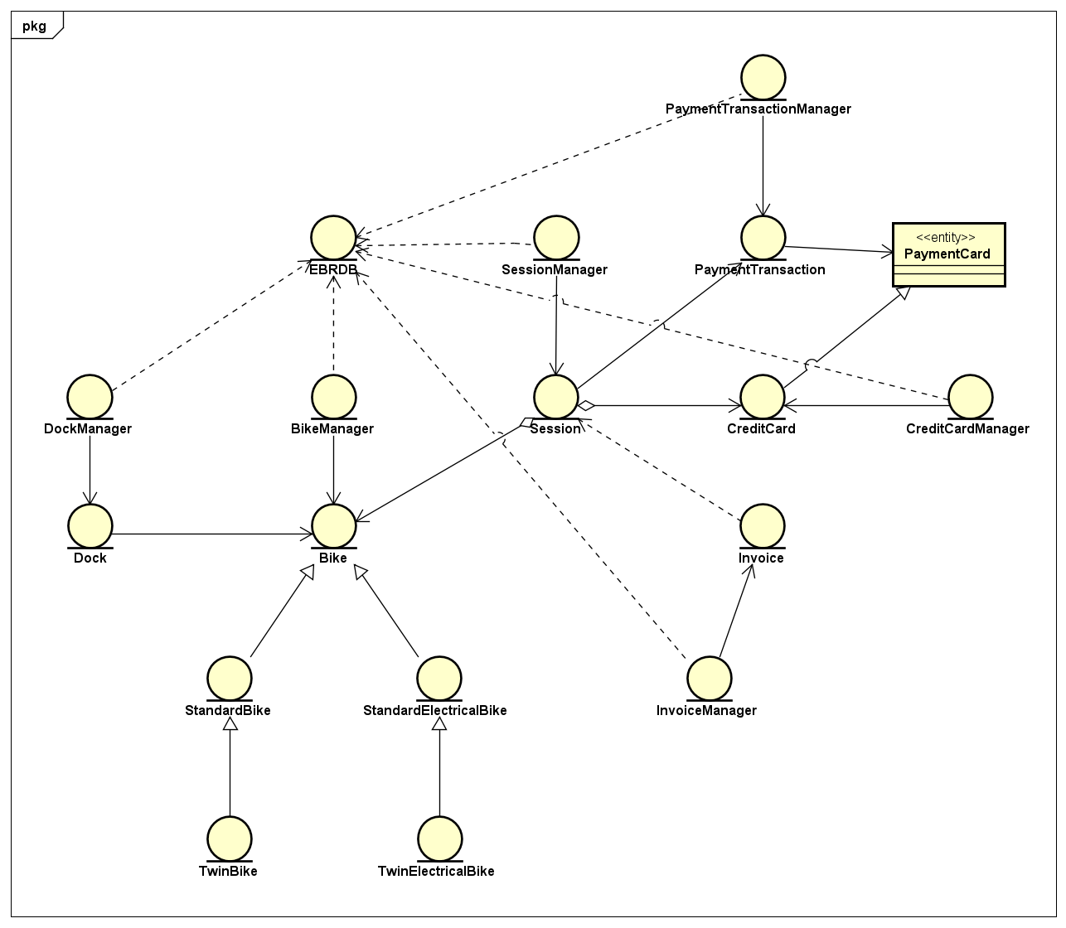

# Class Design

## Class “Bike”

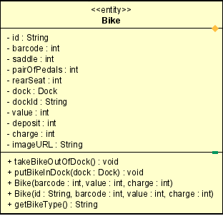

**Attribute**

|  |  |  |  |  |
| --- | --- | --- | --- | --- |
| # | Name | Data type | Default value | Description |
| 1 | id | String | NULL | Bike id |
| 2 | barcode | int | NULL | barcode |
| 3 | saddle | int | NULL | saddle |
| 4 | pairOfPedals | int | NULL | Pair of pedals |
| 5 | rearSeat | int | NULL | Number of rear seats |
| 6 | dock | Dock | NULL | dock |
| 7 | dockId | String | NULL | Dock id |
| 8 | value | int | NULL | value |
| 9 | doposit | int | NULL | deposit |
| 10 | charge | int | NULL | charge |
| 11 | imageURL | String | NULL | Image URL |

**Operation**

|  |  |  |  |
| --- | --- | --- | --- |
| # | Name | Return type | Desciption |
| 1 | takeBikeOutOfDock | void | Take bike out of dock |
| 2 | putBikeInDock | void | Put bike to a dock |
| 3 | getBikeType | String | Get bike type |

Parameter:

dock

Barcode

Value

Charge

id

Exception:

None

**Method**

None

**State**

None

## Class “BikeManager”

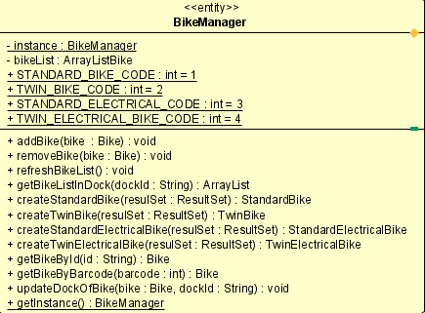

**Attribute**

|  |  |  |  |  |
| --- | --- | --- | --- | --- |
| # | Name | Data type | Default value | Description |
| 1 | instance | BikeManager | NULL | Bike instance |
| 2 | bikeList | ArrayList | NULL | Bike list |
| 3 | STANDARD_BIKE_CODE | int | 1 | Code of standard bike |
| 4 | TWIN_BIKE_CODE | int | 2 | Code of twin bike |
| 5 | STANDARD_ELECTRICAL_BIKE_CODE | int | 3 | Code of standard e bike |
| 6 | TWIN_ELEC TRICAL_BIKE_CODE | int | 4 | Code of twin e bike |

**Operation**

|  |  |  |  |
| --- | --- | --- | --- |
| # | Name | Return type | Desciption |
| 1 | addBike | void | Add bike |
| 2 | removeBike | void | Remove bike |
| 3 | refreshBikeList | void | Refresh bike list |
| 4 | getBikeListInDock | ArrayList | Get bike list in dock |
| 5 | createStandardBike | StandardBike | Create standard bike |
| 6 | createTwinBike | TwinBike | Create twin bike |
| 7 | createStandardEBike | StandardEBike | Create standard e bike |
| 8 | createTwinEBike | TwinEBike | Create twin e bike |
| 9 | getBikeById | Bike | Get bike by id |
| 10 | getBikeByBarcode | Bike | Get bike by barcode |
| 11 | updateDockOfBike | void | Update dock |
| 12 | getInstance | BikeManager | Get bike instance |

Parameter:

bike

DockId

ResultSet

Id – bikeId

barcode

Exception:

None

**Method**

None

**State**

None

## Class “StandardBike”

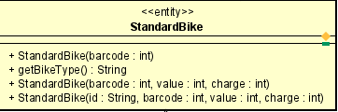

**Attribute**

None

**Operation**

|  |  |  |  |
| --- | --- | --- | --- |
| # | Name | Return type | Desciption |
| 1 | getBikeType | String | Get bike type |

Parameter:

None

Exception:

None

**Method**

None

**State**

None

## Class “StandardElectricalBike”

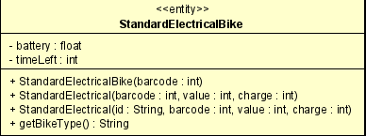

**Attribute**

|  |  |  |  |  |
| --- | --- | --- | --- | --- |
| # | Name | Data type | Default value | Description |
| 1 | battery | float | 100.0 | battery remained |
| 2 | timeLeft | int | NULL | usage time base on battery and bike |

**Operation**

None

Parameter:

None

Exception:

None

**Method**

None

**State**

None

## Class “TwinBike”

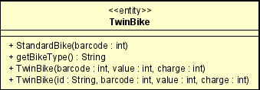

**Attribute**

None

**Operation**

|  |  |  |  |
| --- | --- | --- | --- |
| # | Name | Return type | Desciption |
| 1 | getBikeType | String | Get bike type |

Parameter:

None

Exception:

None

**Method**

None

**State**

None

## Class “TwinElectricalBike”

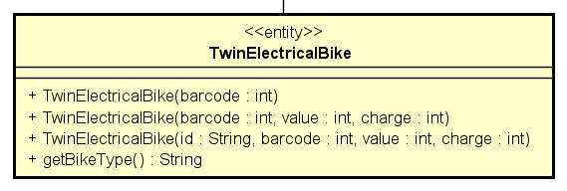

**Attribute**

None

**Operation**

|  |  |  |  |
| --- | --- | --- | --- |
| # | Name | Return type | Desciption |
| 1 | getBikeType | String | Get bike type |

Parameter:

None

Exception:

None

**Method**

None

**State**

None

## Class “EBRDB”

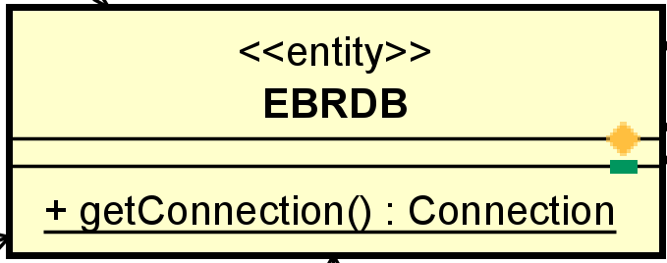

**Attribute**

None

**Operation**

|  |  |  |  |
| --- | --- | --- | --- |
| # | Name | Return type | Desciption |
| 1 | getConnection | Connect | get a connection to PostgreSQL database |

Parameter:

None

Exception:

None

**Method**

None

**State**

None

## Class “Dock”

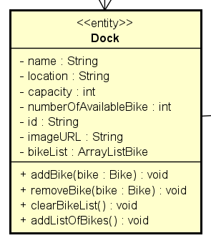 3

**Attribute**

|  |  |  |  |  |
| --- | --- | --- | --- | --- |
| # | Name | Data type | Default value | Description |
| 1 | name | String | NULL | Name of dock |
| 2 | location | String | NULL | Dock location |
| 3 | capacity | int | NULL | Dock size |
| 4 | numberOfAvailableBike | int | NULL | Number of available bikes |
| 5 | id | String | NULL | Dock id |
| 6 | imageURL | String | NULL | Dock image |
| 7 | bikeList | ArrayList<Bike> | NULL | Bike list in dock |

**Operation**

|  |  |  |  |
| --- | --- | --- | --- |
| # | Name | Return type | Desciption |
| 1 | addBike | void | Add bike to dock |
| 2 | removeBike | void | Remove bike out of dock |
| 3 | clearBikeList | void | Clear bike list in dock |
| 4 | addListOfBike | void | Add bike list to dock |

Parameter:

bike

Exception:

None

**Method**

None

**State**

None

## Class “DockManager”

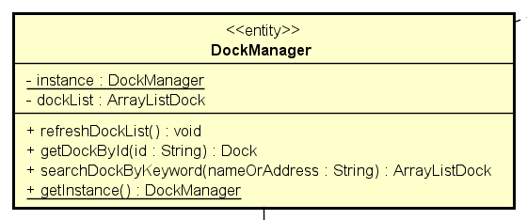

**Attribute**

|  |  |  |  |  |
| --- | --- | --- | --- | --- |
| # | Name | Data type | Default value | Description |
| 1 | instance | DockManager | NULL | Instance of a dock |
| 2 | dockList | ArrayList<Dock> | NULL | Dock list |

**Operation**

|  |  |  |  |
| --- | --- | --- | --- |
| # | Name | Return type | Desciption |
| 1 | refreshDockList | void | Refresh dock list |
| 2 | getDockById | Dock | Get dock by id |
| 3 | searchDockByKeyword | ArrayList<Dock> | Get docks by keyword |
| 4 | getInstance | DockManager | Get dock instance |

Parameter:

Id - dock id

NameOfAddress – dock address

Exception:

None

**Method**

None

**State**

None

## Class “Invoice”

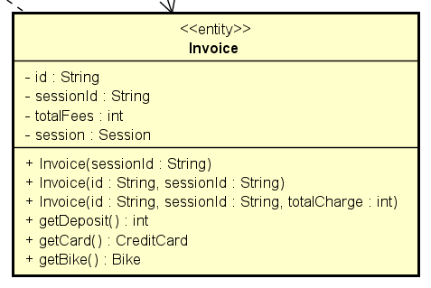

**Attribute**

|  |  |  |  |  |
| --- | --- | --- | --- | --- |
| # | Name | Data type | Default value | Description |
| 1 | id | String | NULL | Invoice id |
| 2 | sessionId | String | NULL | Session id |
| 3 | totalFees | int | NULL | Total charge |
| 4 | session | Session | NULL | Session correspond to invoice |

**Operation**

|  |  |  |  |
| --- | --- | --- | --- |
| # | Name | Return type | Desciption |
| 1 | getDeposit | int | Get deposit |
| 2 | getCard | CreditCard | Get credit card |
| 3 | getBike | Bike | Get bike |

Parameter:

None

Exception:

None

**Method**

None

**State**

None

## Class “InvoiceManager”

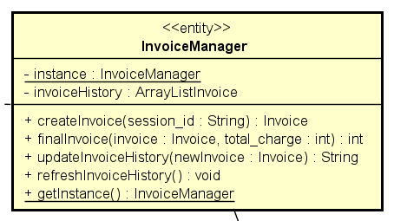

**Attribute**

|  |  |  |  |  |
| --- | --- | --- | --- | --- |
| # | Name | Data type | Default value | Description |
| 1 | instance | DockManager | NULL | Instance of a dock |
| 2 | invoiceHistory | ArrayList<Invoice> | NULL | Invoice History |

**Operation**

|  |  |  |  |
| --- | --- | --- | --- |
| # | Name | Return type | Desciption |
| 1 | createInvoice | Invoice | Create new invoice |
| 2 | finalInvoice | int | Complete invoice |
| 3 | updateInvoiceHistory | String | Update invoice history |
| 4 | refreshInvoiceHistory | void | Refresh invoice history |
| 5 | getInstance | InvoiceManager | Get invoice instance |

Parameter:

Session_id

Invoice

Total_charge

newInvoice

Exception:

None

**Method**

None

**State**

None

## Class “CreditCard”

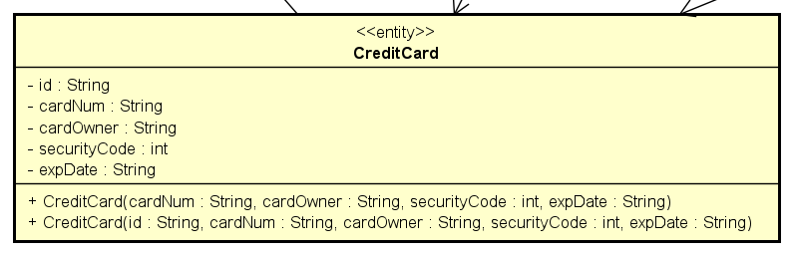

**Attribute**

|  |  |  |  |  |
| --- | --- | --- | --- | --- |
| # | Name | Data type | Default value | Description |
| 1 | id | String | NULL | Card id |
| 2 | cardNum | String | NULL | Card number |
| 3 | cardOwner | String | NULL | Card owner’s name |
| 4 | securityCode | int | NULL | Card security code |
| 5 | expDate | String | NULL | Card exp date |

**Operation**

None

Parameter:

None

Exception:

None

**Method**

None

**State**

None

## Class “CreditCardManager”

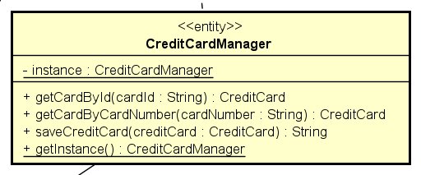

**Attribute**

|  |  |  |  |  |
| --- | --- | --- | --- | --- |
| # | Name | Data type | Default value | Description |
| 1 | instance | CreditCardManager | NULL | Instance of a card |

**Operation**

|  |  |  |  |
| --- | --- | --- | --- |
| # | Name | Return type | Desciption |
| 1 | getCardById | CreditCard | Get card by id |
| 2 | getCardByCardNumber | CreditCard | Get card by card number |
| 3 | saveCreditCard | String | Save credit card |
| 4 | getInstance | CreditCardManager | Get card instance |

Parameter:

CardId – card id

CardNumber – card number

creditCard

Exception:

None

**Method**

None

**State**

None

## Class “PaymentTransaction”

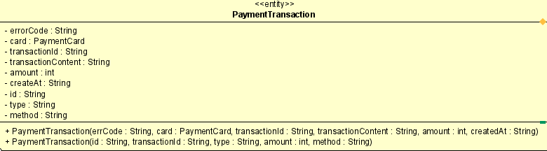

**Attribute**

|  |  |  |  |  |
| --- | --- | --- | --- | --- |
| # | Name | Data type | Default value | Description |
| 1 | errorCode | String | NULL | Error code |
| 2 | card | PaymentCard | NULL | Credit card |
| 3 | transactionId | String | NULL | Transaction id |
| 4 | transactionContent | String | NULL | Contents of transaction |
| 5 | amount | int | NULL | Transaction amount |
| 6 | createAt | String | NULL | Transaction create time |
| 7 | id | String | NULL | PaymentTransaction id |
| 8 | type | String | NULL | Transaction type |
| 9 | method | String | NULL | Transaction method |

**Operation**

None

Parameter:

None

Exception:

None

**Method**

None

**State**

None

## Class “PaymentTransactionManager”

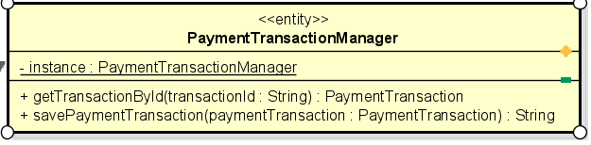

**Attribute**

|  |  |  |  |  |
| --- | --- | --- | --- | --- |
| # | Name | Data type | Default value | Description |
| 1 | instance | PaymentTransaction | NULL | Instance of transaction |

**Operation**

|  |  |  |  |
| --- | --- | --- | --- |
| # | Name | Return type | Desciption |
| 1 | getTransactionById | PaymentTransaction | Get transaction by Id |
| 2 | savePaymentTransaction | String | Save payment transaction |

Parameter:

TransactionId – transaction id

paymentTransaction

Exception:

None

**Method**

None

**State**

None

## Class “Session”

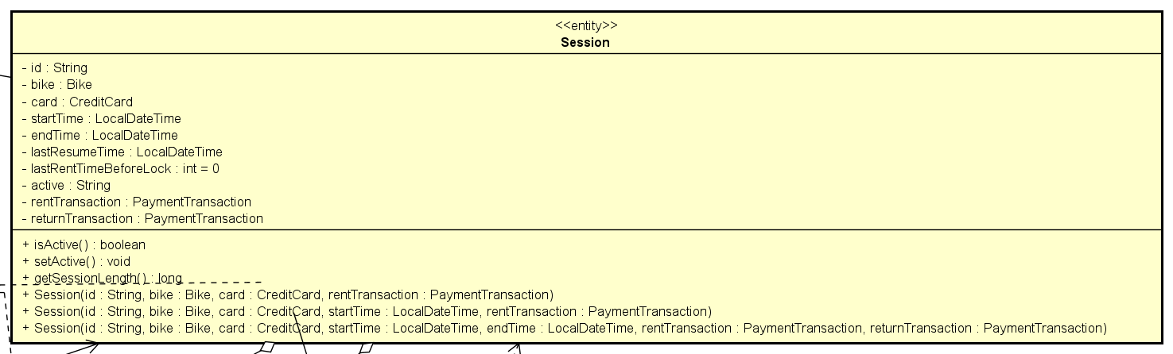

**Attribute**

|  |  |  |  |  |
| --- | --- | --- | --- | --- |
| # | Name | Data type | Default value | Description |
| 1 | id | String | NULL | Session id |
| 2 | bike | Bike | NULL | Bike in session |
| 3 | card | CreditCard | NULL | Card in session |
| 4 | startTime | LocalDateTime | NULL | Start time |
| 5 | endTime | LocalDateTime | NULL | End time |
| 6 | lastResumeTime | LocalDateTime | NULL | Last resume time |
| 7 | lastRentTimeBeforeLock | int | 0 | Last rent time before lock |
| 8 | active | String | NULL | Session active or not |
| 9 | rentTransaction | PaymentTransaction | NULL | Rent transaction |
| 10 | returnTransaction | PaymentTransaction | NULL | Return transaction |

**Operation**

|  |  |  |  |
| --- | --- | --- | --- |
| # | Name | Return type | Desciption |
| 1 | isActive | boolean | Session is active or not |
| 2 | setActive | void | Set session active |
| 3 | getSessionLength | long | Get session length |

Parameter:

None

Exception:

None

**Method**

None

**State**

None

## Class “SessionManager”

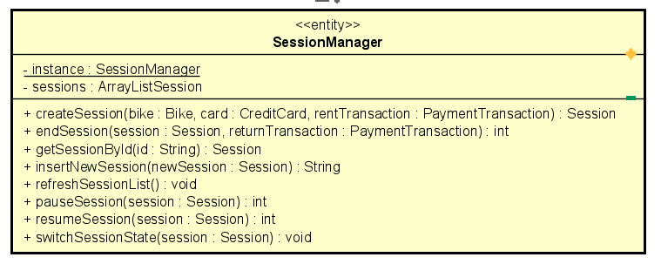

**Attribute**

|  |  |  |  |  |
| --- | --- | --- | --- | --- |
| # | Name | Data type | Default value | Description |
| 1 | instance | SessionManager | NULL | Session instance |
| 2 | sessions | ArrayList<Session> | NULL | Session list |

**Operation**

|  |  |  |  |
| --- | --- | --- | --- |
| # | Name | Return type | Desciption |
| 1 | createSession | Session | Create a session |
| 2 | endSession | int | Complete session |
| 3 | getSessionById | Session | Get session by id |
| 4 | insertNewSession | String | Insert new session to db |
| 5 | refreshSessionList | void | Refresh session list |
| 6 | pauseSession | int | Pause session |
| 7 | resumeSession | int | Resume session |

Parameter:

Bike

Card

PaymentTransaction

Session

newSession

Exception:

None

**Method**

None

**State**

None

# Class Diagram

